Project <Project Name>

<System Name>

Software Requirements Specification (SRS) for [TBD]

|  |  |  |  |  |  |  |  |
| --- | --- | --- | --- | --- | --- | --- | --- |
| CDRL: |  | Spec Refs: |  |  |  |  |  |
| <CDRL> |  | <Spec Refs> |  |  |  |  |  |
| Prepared: |  | <Prepared Name> |  |  |  | signed: |  |
|  |  | <Prepared Title> |  | Signature |  | yyyy-mm-dd |  |
| Verified: |  | <Verified Name> |  |  |  | signed: |  |
|  |  | <Verified Title> |  | Signature |  | yyyy-mm-dd |  |
| Approved: |  | <Approved Name> |  |  |  | signed: |  |
|  |  | <Approved Title> |  | Signature |  | yyyy-mm-dd |  |
| This document and its contents are the property of ANNAX information systems AG or its subsidiaries. The reproduction, distribution, utilization or the communication of this document or any part thereof, without express authorisation is strictly prohibited. Offenders will be held liable for the payment of damages. | | |  | Identity Number: |  | <Document Number> |  |
|  | Revision: |  | <Revision Level> |  |
|  | Status: |  | Draft |  |
|  | Date (yyyy-mm-dd): |  | 2011-08-04 |  |

Revision History

|  |  |  |  |
| --- | --- | --- | --- |
| Revision | Date  (yyyy-mm-dd) | Initials | Description of Changes |
|  |  |  | You may want to put „First issue“ here for the first version of the document |
|  |  |  |  |
|  |  |  |  |
|  |  |  |  |
|  |  |  |  |

Table of Contents

1 Introduction 5

1.1 Purpose 5

1.2 Scope 5

1.3 Definitions, Acronyms, and Abbreviations 6

1.4 References 6

1.5 Overview 7

1.6 Maintenance 7

2 Overall Description 9

2.1 Product Perspective 9

2.1.1 System Interfaces 10

2.1.2 User Interfaces 11

2.1.3 Hardware Interfaces 11

2.1.4 Software Interfaces 11

2.1.5 Communication Interfaces 11

2.1.6 Memory Constraints 11

2.1.7 User Operations 11

2.1.8 Site Adaptation Requirements 11

2.2 Product Functions 11

2.3 User Characteristics 12

2.4 Constraints 12

2.5 Assumptions and Dependencies 12

2.6 Apportioning of Requirements 13

3 Specific Requirements 14

3.1 External Interfaces 14

3.1.1 User Interfaces 14

3.1.2 Hardware Interfaces 14

3.1.3 Software Interfaces 14

3.1.4 Communication Interfaces 14

3.1.5 Other Interfaces 14

3.2 Functions OR Classes/Objects OR Features 14

3.2.1 Function/Mode/Stimulus/Process/User (n) 15

3.2.2 Classes/Objects 16

3.2.3 Feature (n) 16

3.3 Performance Requirements 17

3.3.1 Static Numerical 17

3.3.2 Dynamic Numerical 18

3.4 Logical Database Requirements 18

3.5 Design Constraints 18

3.5.1 Standards Compliance 18

3.5.2 Hardware Limitations 18

3.5.3 Other Constraints 19

3.6 Software System Attributes 19

3.6.1 Reliability 19

3.6.2 Availability 19

3.6.3 Security 19

3.6.4 Maintainability 19

3.6.5 Portability 19

3.6.6 Attribute (n) 20

Attachment A: Index of Requirements 21

List of Figures

Figure 1: Context Diagram of the [TBD software product name] 10

List of Tables

Table 1: List of Acronyms and Definitions 6

Table 2: List of References 7

# Introduction

[TBD – Make sure you have the correct master template (ANNAX Template for Technical Documents.dotm) correctly installed in the correct location (see hints in the master template).

Please evoke the “Document Information” dialog by pressing **SHIFT+F10** in order to enter document information like e.g. document title and document number.

This SRS template contains **explanatory hidden text**. Pressing **ALT+H** will **toggle on/off** hidden text. Please remove this paragraph as well as all hidden text in the document before or when you finalize the SRS.]

Removal of hidden text is supported by a Word macro: Pressing SHIFT+F10 will evoke a dialog. Clicking „Finalize document“ will remove all hidden text automatically.

Please leave the structure of the SRS – if not otherwise stated – unchanged. This will facilitate re-use of document content in future projects and is a prerequisite for conformance of the SRS with IEEE Standards 830-1998 and 1558-2004.

Contents of the SRS:

A „good“ SRS should contain sufficient details for all readers and should provide a solid basis for documents based on the SRS, for example the Software Design Description and the Software Test Procedure.

## Purpose

[I830] S5.1.1: „This subsection should

a) Delineate the purpose of the SRS;

b) Specify the intended audience for the SRS.“

Pertaining questions from an ANNAX customer’s checklist:

(1) Is the purpose of the SRS defined?

(2) Is the intended audience of the SRS specified?”

## Scope

[I830] S5.1.2: „This subsection should

a) Identify the software product(s) to be produced by name (e.g., Host DBMS, Report Generator, etc.);

b) Explain what the software product(s) will, and, if necessary, will not do;

c) Describe the application of the software being specified, including relevant benefits, objectives, and goals;

d) Be consistent with similar statements“

Pertaining questions from an ANNAX customer’s checklist:

1. Is the SCI to be produced identified?
2. Is what the software product(s) will, and, if necessary will not do explained?
3. Is the application of the software described?
4. Does the SRS include a compliance statement to higher-level specifications?

## Definitions, Acronyms, and Abbreviations

The following acronyms and definitions are used within this SRS.

Please add all acronyms and their definitions. Delete all acronyms not used in this document from the table before finalizing the document.

Pertaining questions from an ANNAX customer’s checklist:

1. Are all the acronyms used in this document listed?
2. Are there definitions for the terms used in this document which may not be explicitly understood by the target audience of this document, including external entities (customers, or other third party)?

Table : List of Acronyms and Definitions

| Acronym | Definition |
| --- | --- |
|  |  |
| IEEE | Institute of Electrical and Electronics Engineers |
| SCI | Software Configuration Item |
| SDD | Software Design Description |
| SRS | Software Requirements Specification |
|  |  |
|  |  |
|  |  |
|  |  |
|  |  |
|  |  |
|  |  |
|  |  |

## References

The following documents are referenced within this SRS:

Please add all documents referenced in this document. Use the format [...] for the references.

Pertaining questions from an ANNAX customer’s checklist:

1. Are all documents referenced elsewhere in the SRS listed?
2. Is each document identified by title, report number (if applicable), date, and publishing organization?
3. Are the sources from which the references can be obtained identified (if applicable)?

Table : List of References

| Doc ID | Document Description |
| --- | --- |
| TBD |  |
| [I830] | IEEE Std 930-1998 - IEEE Recommended Practice for Software Requirements Specifications |
| [I1558] | IEEE Std 1558-2004 - IEEE Standard for Software Documentation for Rail Equipment and Systems |
|  |  |

## Overview

[I830] S5.1.5: „This subsection should

a) Describe what the rest of the SRS contains;

b) Explain how the SRS is organized.“

The following text is only a sample and should be changed.

Pertaining questions from an ANNAX customer’s checklist:

1. Does this section describe what the rest of SRS contains?
2. Does this section explain how SRS is organized?

This SRS contains the requirements related to the SCIs of the [TBD], with a focus on functional requirements. Detailed design information is not contained in this document and will be included in a separate document, the Software Design Description (SDD).

The document is organized into following sections:

Section 1 - (Introduction - This section)

Section 2 - Overall Description, describing the general factors that affect the [TBD].

Section 3 - Specific Requirements, describing the detailed requirements of the [TBD software product name]

## Maintenance

Please describe here the events triggering a revision of the SRS and the responsibilities (who will update/verify/approved the document. Sample text (only useful if a SQAP exists):

Maintenance of this SRS will be according to the stipulations in the project’s Software Quality Assurance Plan [TBD Document reference].

Pertaining questions from an ANNAX customer’s checklist:

(1) Does this section contain the procedure (including the responsibility) to modify and maintain the SRS?

# Overall Description

The following sentence is only a sample. You may change it.

This section is intended to provide readers of this document with context information for the software requirements stipulated in Section 3.

## Product Perspective

[TBD Put your text here]

Figure 1 depicts the context of the [TBD software product name].



Figure 1: Context Diagram of the [TBD software product name]

Please change/replace the figure above to correctly reflect the context of the SW described in this SRS.

### System Interfaces

Pertaining questions from an ANNAX customer’s checklist:

(1) Does this section describe the system interfaces that affect the product and its requirements?

### User Interfaces

Pertaining questions from an ANNAX customer’s checklist:

(1) Does this section describe the user interfaces that affect the product and its requirements (if applicable)?

### Hardware Interfaces

Pertaining questions from an ANNAX customer’s checklist:

(1) Does this section describe the user interfaces that affect the product and its requirements (if applicable)?

### Software Interfaces

Pertaining questions from an ANNAX customer’s checklist:

(1) Does this section describe the hardware interfaces that affect the product and its requirements?

### Communication Interfaces

Pertaining questions from an ANNAX customer’s checklist:

(1) Does this section describe the communication interfaces that affect the product and its

requirements (if applicable)?

### Memory Constraints

Pertaining questions from an ANNAX customer’s checklist:

(1) Does this section describe the memory constraints that affect the product and its requirements (if applicable)?

### User Operations

Pertaining questions from an ANNAX customer’s checklist:

(1) Does this section describe the special operations that affect the product and its requirements (if

applicable)?

### Site Adaptation Requirements

Pertaining questions from an ANNAX customer’s checklist:

(1) Does this section describe the site adaptation that may be required before launching the software into operation?

## Product Functions

Please describe here the major functions the SW will perform

Pertaining questions from an ANNAX customer’s checklist:

(1) Does this section describe the major functions of the software will perform?

## User Characteristics

[IEEE830] S5.2.3: „This subsection of the SRS should describe those general characteristics of the intended users of the product including educational level, experience, and technical expertise. It should not be used to state specific requirements, but rather should provide the reasons why certain specific requirements are later specified in Section 3 of the SRS.“

Pertaining questions from an ANNAX customer’s checklist:

(1) Does this section describe the general characteristics of the intended user of the software

(if applicable)?

## Constraints

[IEEE830] S5.2.4: „This subsection of the SRS should provide a general description of any other items that will limit the developer‘s options. These include

a) Regulatory policies;

b) Hardware limitations (e.g., signal timing requirements);

c) Interfaces to other applications;

d) Parallel operation;

e) Audit functions;

f) Control functions;

g) Higher-order language requirements;

h) Signal handshake protocols (e.g., XON-XOFF, ACK-NACK);

i) Reliability requirements;

j) Criticality of the application;

k) Safety and security considerations.“

Pertaining questions from an ANNAX customer’s checklist:

(1) Does this section provide a general description of any constraint that will limit the developer’s options?

## Assumptions and Dependencies

[IEEE830] S5.2.5: „This subsection of the SRS should list each of the factors that affect the requirements stated in the SRS.

These factors are not design constraints on the software but are, rather, any changes to them that can affect the requirements in the SRS. For example, an assumption may be that a speciÞc operating system will be available on the hardware designated for the software product. If, in fact, the operating system is not available, the SRS would then have to change accordingly.“

Pertaining questions from an ANNAX customer’s checklist:

(1) Does this section list all the factors that affect the requirements of the SRS?

## Apportioning of Requirements

[IEEE830] S5.2.6: „This subsection of the SRS should identify requirements that may be delayed until future versions of the system.“

Pertaining questions from an ANNAX customer’s checklist:

(1) Does this section identify requirements that may be delayed until future version of the system (if

applicable)?

# Specific Requirements

## External Interfaces

### User Interfaces

Recommended / not mandatory according to [I1558].

Pertaining questions from an ANNAX customer’s checklist:

(1) Are the user inputs and outputs from SCI adequately described?

### Hardware Interfaces

Recommended / not mandatory according to [I1558].

Pertaining questions from an ANNAX customer’s checklist:

(1) Are the hardware inputs and outputs from SCI adequately described?

### Software Interfaces

Recommended / not mandatory according to [I1558].

Pertaining questions from an ANNAX customer’s checklist:

(1) Are the software inputs and outputs from SCI adequately described?

### Communication Interfaces

Recommended / not mandatory according to [I1558].

Pertaining questions from an ANNAX customer’s checklist:

(1) Are the communication inputs and outputs from SCI adequately described?

### Other Interfaces

Recommended / not mandatory according to [I1558].

Pertaining questions from an ANNAX customer’s checklist:

(1) Does this section describe any other interfaces (if applicable)?

## Functions OR Classes/Objects OR Features

According [I1558], either functions OR classes/objects or features to be described. Please choose one of the options, change the headline and delete the not used sample headlines of the subsections 3.2.n !

Pertaining questions from an ANNAX customer’s checklist:

(1) For each functional requirement, are the purpose, data (inputs/outputs) and processing described?

### Function/Mode/Stimulus/Process/User (n)

[I1558]: “Each function/mode/stimulus/process/user shall have a unique subsection number.”

Please provide a specific headline for all subsections (3.2.n), e.g. “Time Synchronization”

Here is sample (not mandatory) organization of Section 3.2 based on modes according to [I830]

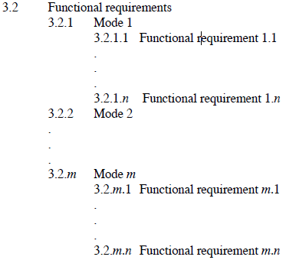

Another sample, based on user classes:

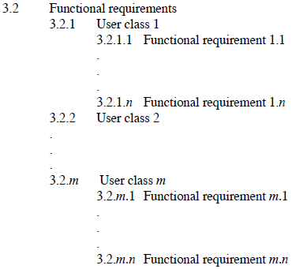

Recommendation: In order to facilitate traceability of requirements, it is recommended to identify each requirement with a unique identifier. A sample identification scheme is given here:

With “ABC” = the SW product name:

[ABC_FCT_REQ_001] = functional requirement no. 001

[ABC_PFC_REQ_001] = performance requirement no. 001

[ABC_SSA_REQ_001] = software system attribute requirement no. 001

[[TBD – SW Product Name]_FCT_REQ_001]

### Classes/Objects

Alternative organization of Section 3.2.  
Here is a sample (not mandatory) organization of Section 3.2 based on classes/objects according to [I830]



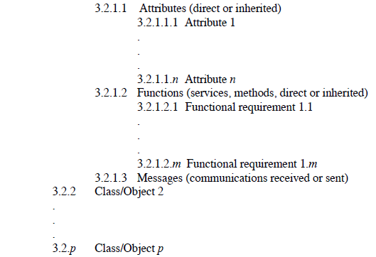

### Feature (n)

Alternative organization of Section 3.2.  
Here is a sample (not mandatory) organization of Section 3.2 based on features according to [I830]

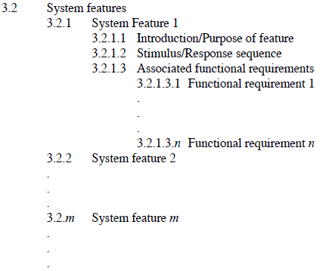

## Performance Requirements

[I830] S5.3.3: „This subsection should specify both the static and the dynamic numerical requirements placed on the software or on human interaction with the software as a whole. Static numerical requirements may include the following:

a) The number of terminals to be supported;

b) The number of simultaneous users to be supported;

c) Amount and type of information to be handled.

Static numerical requirements are sometimes identiÞed under a separate section entitled Capacity.

Dynamic numerical requirements may include, for example, the numbers of transactions and tasks and the amount of data to be processed within certain time periods for both normal and peak workload conditions. All of these requirements should be stated in measurable terms.

For example,

95% of the transactions shall be processed in less than 1 s.

rather than,

An operator shall not have to wait for the transaction to complete.

NOTE: Numerical limits applied to one specific function are normally specified as part of the processing subparagraph description of that function.“

### Static Numerical

Pertaining questions from an ANNAX customer’s checklist:

(1) Are static numerical requirements measurable (if applicable)?

### Dynamic Numerical

Pertaining questions from an ANNAX customer’s checklist:

(1) Are dynamic numerical requirements measurable (if applicable)?

## Logical Database Requirements

[I830] S5.3.4: „This should specify the logical requirements for any information that is to be placed into a database. This may include the following:

a) Types of information used by various functions;

b) Frequency of use;

c) Accessing capabilities;

d) Data entities and their relationships;

e) Integrity constraints;

f) Data retention requirements.“

Pertaining questions from an ANNAX customer’s checklist:

(1) Are logical database requirements described in this section (if applicable)?

## Design Constraints

[I830] S5.3.5: „This should specify design constraints that can be imposed by other standards, hardware limitations, etc.“

### Standards Compliance

[I830] S5.3.51: „This subsection should specify the requirements derived from existing standards or regulations. They may include the following:

a) Report format;

b) Data naming;

c) Accounting procedures;

d) Audit tracing.

For example, this could specify the requirement for software to trace processing activity. Such traces are needed for some applications to meet minimum regulatory or Þnancial standards. An audit trace requirement may, for example, state that all changes to a payroll database must be recorded in a trace Þle with before and after values.“

Pertaining questions from an ANNAX customer’s checklist:

(1) Does this section specify requirements derived from existing standards or regulations (if applicable)?

### Hardware Limitations

Recommended / not mandatory according to [I1558].

Pertaining questions from an ANNAX customer’s checklist:

(1) Does this section specify requirements derived from existing standards or regulations (if applicable)?

### Other Constraints

Recommended / not mandatory according to [I1558].

Pertaining questions from an ANNAX customer’s checklist:

(1) Does this section identified and describe any other constraints (if applicable)?

## Software System Attributes

### Reliability

Pertaining questions from an ANNAX customer’s checklist:

1. Does this section address the reliability of the software in order to meet system reliability (if applicable)?

### Availability

Pertaining questions from an ANNAX customer’s checklist:

(1) Does this section address the reliability of the software in order to meet system reliability (if applicable)?

### Security

Pertaining questions from an ANNAX customer’s checklist:

(1) Does this section address the reliability of the software in order to meet system reliability (if applicable)?

### Maintainability

Pertaining questions from an ANNAX customer’s checklist:

(1) Does this section address the maintainability of the

software (if applicable)?

### Portability

Pertaining questions from an ANNAX customer’s checklist:

(1) Does this section address the portability of the software (if applicable)?

### Attribute (n)

Recommended / not mandatory according to [I1558]. Delete the headline 3.6.6 if this subsection is not needed.

Attachment A: Index of Requirements

Please delete the headline and the index if no index is used.

[[TBD – SW Product Name]_FCT_REQ_001] Function/Mode/Stimulus/Process/User (n) 16